

**35-127 M**

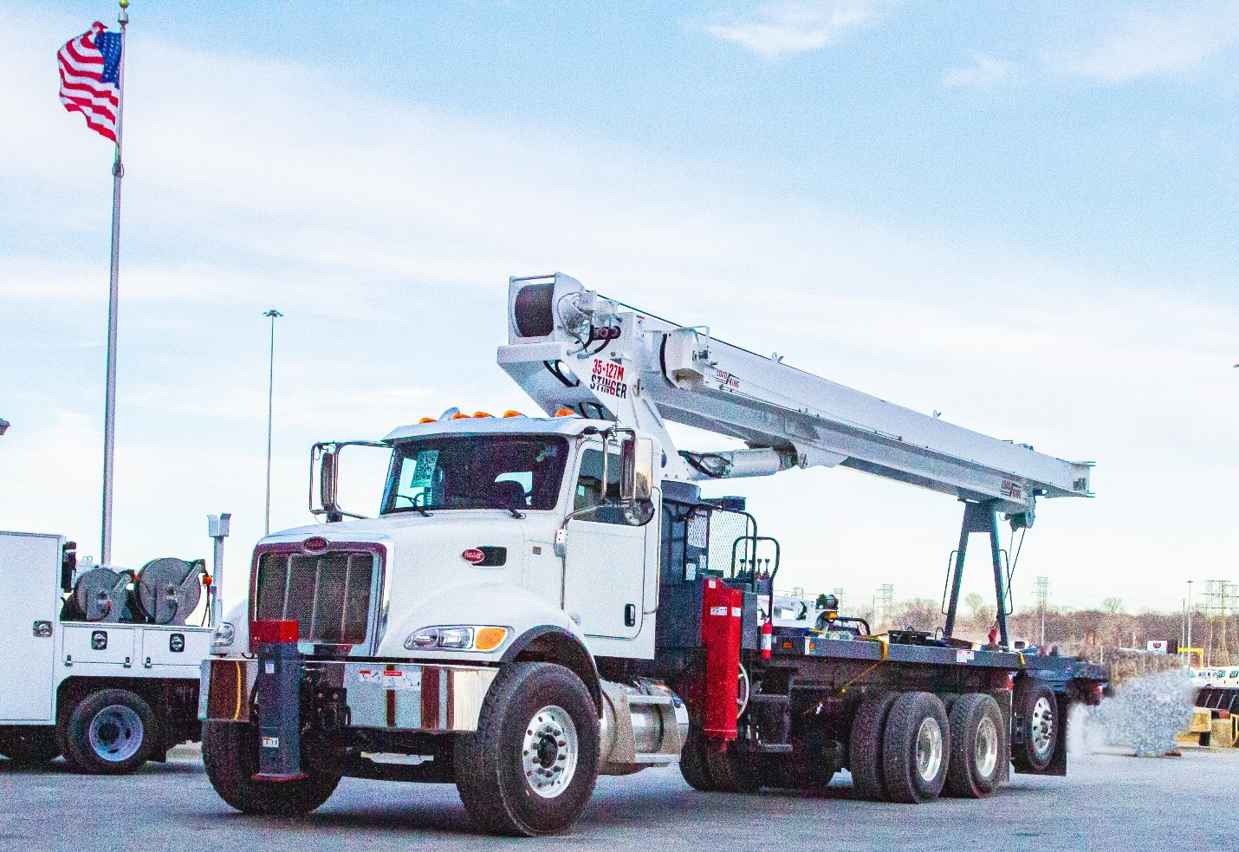

**Features of the Stinger 35-127 M:**

Piggy-back hydraulic tank improves weight distribution and stowage.

* 5-section proportional 127-foot high-strength steel keel boom
* M-style multi-position outriggers (full, mid and zero span)
* Maximum tip height of 192 feet with optional two-piece 55-foot jib
* Winch control at the rear of the crane
* Dual stand-up control stations
* Direct linkage operation for crane functions
* Electric control over outriggers
* Electronic rated capacity indicator with integrated work area definition
* Standard oil cooler
* Front bumper outrigger required for 360-degree operation
* Available with remote controls and our new yoke-style basket
* Available with standard or super duty wood or steel beds.

**Main Boom, Full Outriggers, 360 Degrees**



**Layout Drawing**

